Ms. Thompson’s Behavior System
Dear Parents,
I am so excited to have your child in my class this year! In order to help keep our classroom running smoothly and to hold students accountable for their behavior, we have a management system in our class that I would like to explain to you, so you will know what to expect this year, be able to follow up at home with your child each day, and help your child to set goals for positive behavior.
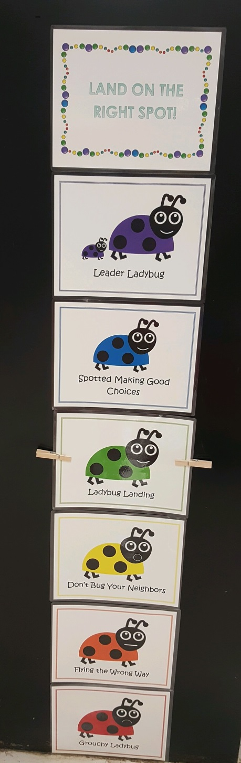
In our classroom, we have a clip chart that has 6 different colors on it. Each day, your child will start out on the color in the middle of the chart, GREEN, which is “Ladybug Landing.” Throughout the day, your child has the opportunity to move his or her clip up the chart for positive behavior choices or down the chart for negative behavior choices.
At the beginning of each month, I will send home a behavior calendar that has a square for each day we are in school. This calendar will stay in your child’s folder all month long. At the end of each day, your child will color in the circle in the calendar square on his or her behavior calendar to correspond with the color that he or she ended up on our clip chart. If your child moved his or her clip to YELLOW, “Don’t Bug Your Neighbors,” this means that your child had to have a verbal warning for something, but he or she stopped the behavior after the warning and had an okay rest of the day. If your child moved his or her clip to ORANGE “Flying the Wrong Way,” or RED “Grouchy Ladybug,” this means that your child was warned about his or her behavior yet continued to make poor behavior choices that disrupted learning in the classroom. If this happens, you will also see a number in the square which corresponds to the Behavior Code at the bottom of the calendar. This number will give you more information about what specific behaviors your child struggled with that day. This number may be in addition to a phone call or email from me if I feel that the issue was particularly concerning or serious in nature. If your child comes home with an ORANGE or RED square, I would highly recommend that you give a consequence at home in addition to the one given at school so your child knows that poor behavior is not tolerated and understands that there will be consequences at home if poor behavior continues.
If your child comes home with a behavior calendar colored in GREEN, “Ladybug Landing,” that means he or she had a great day and was making good choices! If your child comes home with BLUE, “Spotted Making Good Choices,” that means he or she was trying extra hard to make good choices and really stood out above the other students that particular day. If your child comes home with PURPLE, “Leader Ladybug” that means your child went above and beyond to show me what a fabulous leader they are and deserves a real pat on the back!! (As an added incentive to do his or her best, you may choose to give your child something extra special if he or she meets the goal of getting to “Leader Ladybug”). If your child gets the privilege of making it to “Leader Ladybug,” he or she will have the opportunity to visit our class treasure box.
Expect a rainbow of colors the first month or two of school as I am setting expectations and they are still getting accustomed to our classroom routines. Please make sure that you check your child’s behavior calendar EVERY night and that you initial above each day’s square. Thank you in advance! :)

If you have any questions about our classroom management system, please feel free to contact me, and I will do my best to clear up any confusion. Thank you for your support of our classroom management system. I am looking forward to a wonderful year!!

Sincerely,
Ms. Thompson

